**xVIVEKANAND EDUCATION SOCIETY INSTITUTE OF**

**TECHNOLOGY**

**CHEMBUR, MUMBAI - 400704**



Fuzzy C-Means Clustering Technique

Content Beyond Syllabus

October 7th, 2023

A REPORT ON

**Fuzzy C-Means Clustering Technique**

BY

D11AD - GROUP NO. 5

|  |  |
| --- | --- |
| 59 | Mrunal Shinde |
|  |  |
| 66 | Ajay Nambiar |
|  |  |
| 67 | Chaitali Gaikwad |
|  |  |
| 68 | Kapil Bodas |
|  |  |

**TABLE OF CONTENTS**

PROBLEM STATEMENT 3

INTRODUCTION 4

OBJECTIVES 5

ALGORITHM 7

EXAMPLE 9

PERFORMANCE EVALUATION 11

APPLICATIONS 13

ADVANTAGES 15

DISADVANTAGES 16

CONCLUSION 17

# **PROBLEM STATEMENT**

In today's data-driven world, making sense of large and complex datasets is a critical challenge. Traditional clustering techniques, like K-Means, assign each data point to a single cluster, assuming clear boundaries between groups. However, many real-world scenarios involve data points that don't fit neatly into one category. This limitation presents a problem for accurate data analysis and decision-making. Therefore, the need arises for a more flexible clustering method that can handle data with varying degrees of membership to multiple groups.

Fuzzy C-Means (FCM) clustering offers a solution to this problem by allowing data points to belong partially to multiple clusters. FCM assigns 'degrees of membership' to each data point, reflecting the strength of association with different clusters. This enables us to deal with the inherent ambiguity and uncertainty in many real-world datasets.

In this presentation, we will explore the concept of Fuzzy C-Means clustering, its applications across various domains, and how it overcomes the limitations of traditional clustering methods.

We will also delve into the mathematical foundations and practical implementation of FCM, showcasing its potential to uncover hidden patterns and insights in complex data. By understanding Fuzzy C-Means clustering, we can address the challenge of handling uncertain and overlapping data, leading to more accurate and robust data analysis and decision-making.

# **INTRODUCTION**

Fuzzy C-Means (FCM) is a clustering algorithm used in data analysis and pattern recognition. It is an extension of the K-Means clustering algorithm that allows data points to belong to multiple clusters with varying degrees of membership or "fuzziness." FCM is particularly useful when dealing with data points that may not clearly belong to a single cluster. Like K-Means, FCM starts by initializing a set of cluster centroids. These centroids are typically chosen randomly or using some other method. For each data point in the dataset, FCM calculates the degree to which it belongs to each cluster. This is done using a membership function that assigns a membership value between 0 and 1 for each cluster. The membership values represent the degree of association between a data point and a cluster. After calculating the membership degrees, FCM updates the cluster centroids. The centroids are recalculated as weighted averages of the data points, where the weights are determined by the membership degrees. Data points that have. Once the algorithm converges, each data point is assigned to one or more clusters based on its membership degrees. Data points with high membership values for a particular cluster are considered to belong more strongly to that cluster. The final output of the FCM algorithm is a set of cluster centroids and the membership degrees for each data point. These results can be used for various purposes, such as data segmentation, pattern recognition, or decision-making. The fuzziness parameter (usually denoted as "m") in FCM determines how much each data point can belong to multiple clusters. A higher value of "m" makes the memberships more fuzzy, allowing data points to belong to multiple clusters with more balanced membership values.

# **OBJECTIVES**

Fuzzy C-means (FCM) is a clustering algorithm that assigns data points to clusters based on fuzzy membership degrees. The objective of FCM is to minimize a certain criterion function that represents the fuzziness of the clustering. Here are the main objectives of the Fuzzy C-means clustering algorithm:

* **Minimize the Objective Function (J_m):**

The primary objective of FCM is to minimize the objective function, often denoted as J_m. This function comprises the weighted sum of squared deviations of each data point from the cluster centers, weighted by the membership degrees.

* **Optimize Cluster Centers (Centroids):**

FCM aims to find the optimal cluster centers (centroids) by iteratively adjusting them based on the membership degrees and data point distances. The centroids should represent the "centers" of the clusters to minimize the overall fuzziness.

* **Determine Fuzzy Membership Degrees:**

FCM calculates the membership degrees for each data point with respect to each cluster. These degrees indicate the likelihood of a data point belonging to a particular cluster and are constrained to the range [0, 1].

* **Achieve Fuzzy Partitioning:**

FCM's objective is to achieve a soft or fuzzy partitioning of data points into clusters. This means allowing a data point to belong to multiple clusters to varying degrees, providing a more flexible representation of data distribution.

* **Enhance Robustness to Noisy Data:**

FCM aims to provide robustness against noise and outliers in the data. By assigning membership degrees rather than hard assignments, FCM can handle data points that do not clearly belong to a single cluster.

* **Iteratively Update Memberships and Cluster Centers:**

FCM iteratively updates the membership degrees and cluster centers to converge to a stable solution. The updates are based on minimizing the objective function and adjusting memberships accordingly.

* **Balancing Compactness and Separation:**

FCM strives to strike a balance between compactness of clusters (minimizing intra-cluster variance) and separation between clusters (maximizing inter-cluster variance) to achieve meaningful and well-separated clusters.

* **Adapt to Varying Fuzziness Levels:**

FCM allows for the adjustment of the fuzziness parameter (often denoted as "m") to adapt to different levels of fuzziness or uncertainty in the data. This ensures the algorithm can accommodate different data types and scenarios effectively.

* **Converge to a Stable Solution:**

The ultimate objective of FCM is to converge to a stable solution where the cluster centers and membership degrees no longer significantly change between iterations, indicating that the clustering is well-defined and representative of the data distribution.

# **ALGORITHM**

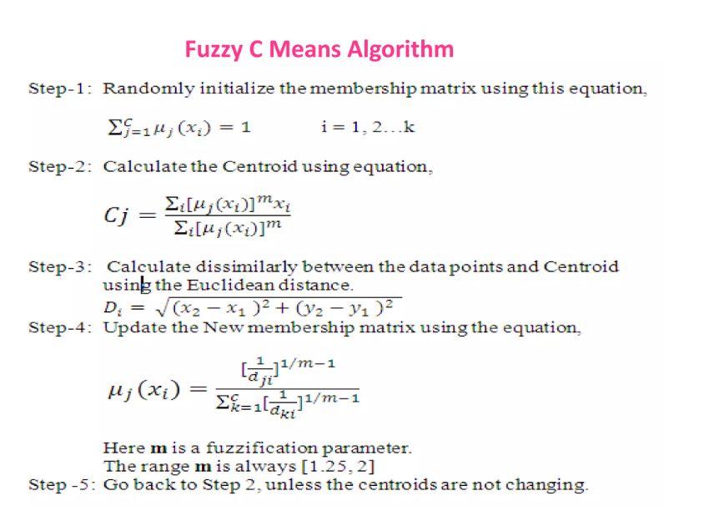

Assume a fixed number of clusters k.

**Initialization**: Randomly initialize the k-means μk associated with the clusters and compute the probability that each data point xi is a member of a given cluster k, P(point xi has label k|xi, k).

**Iteration**: Recalculate the centroid of the cluster as the weighted centroid given the probabilities of membership of all data points xi:

**Termination**: Iterate until convergence or until a user-specified number of iterations has been reached (the iteration may be trapped at some local maxima or minima).

# EXAMPLE

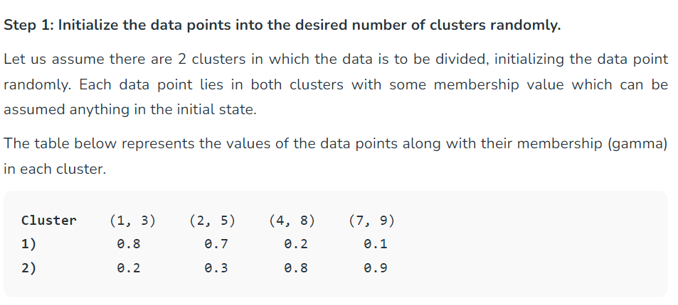

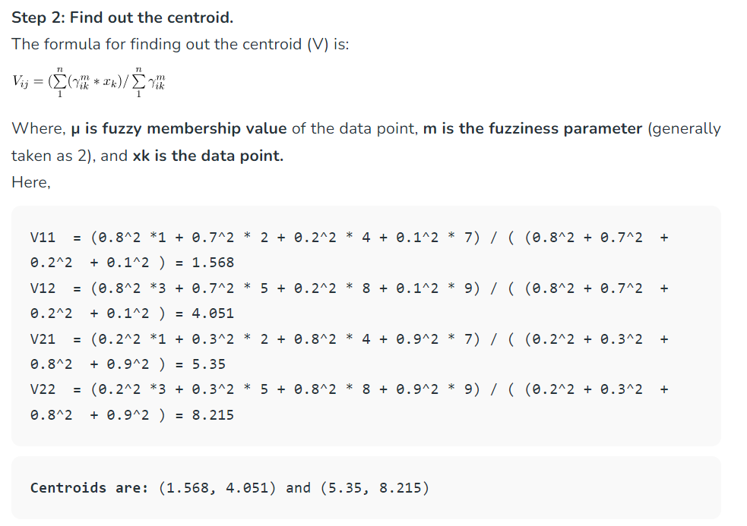

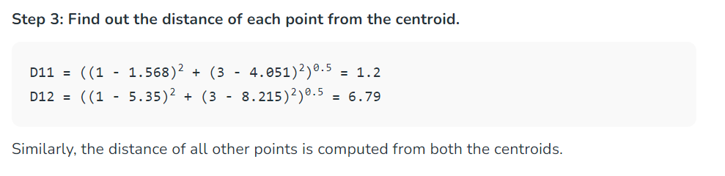

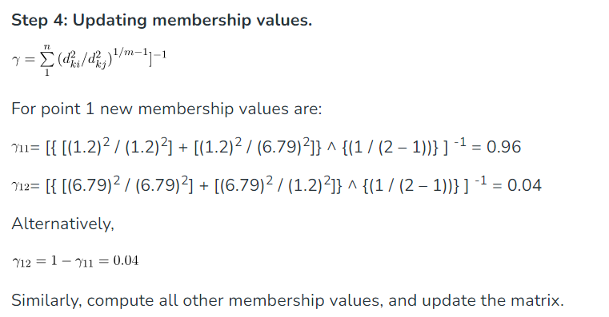

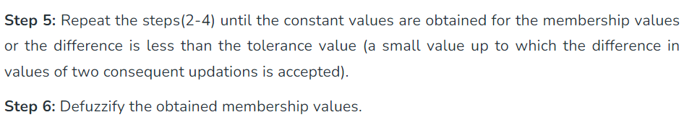

# **PERFORMANCE EVALUATION**

On Comparing the performance of Fuzzy C-means (FCM) and K-means clustering algorithms the following can be summarized:

**1. Clustering Flexibility**:

- FCM: FCM allows for a more flexible and nuanced clustering by assigning each data point a degree of membership to multiple clusters. This flexibility accommodates scenarios where a data point may belong to more than one cluster.

- K-means: K-means assigns a data point to a single cluster, making it less flexible compared to FCM. Each point belongs exclusively to the cluster with the closest centroid.

**2. Cluster Interpretability**:

- FCM: FCM provides membership degrees for each data point, indicating the strength of its association with each cluster. This allows for a more detailed understanding of how a point relates to multiple clusters.

- K-means: K-means provides hard assignments, making cluster interpretation simpler as each point belongs to a single cluster with no ambiguity.

**3. Handling Noisy Data and Outliers:**

- FCM: FCM is more robust in handling noisy data or outliers due to its soft assignment nature, where a data point can have partial membership in multiple clusters.

- K-means: K-means is sensitive to outliers and noisy data, potentially leading to inaccurate cluster assignments.

**4. Cluster Shape and Size:**

- FCM: FCM can handle clusters with different shapes and sizes more effectively, as it considers the membership degrees and the overall data distribution.

- K-means: K-means assumes spherical clusters of roughly equal sizes, which can lead to suboptimal results if the data does not conform to this assumption.

**5. Convergence and Speed:**

- FCM: FCM usually takes more iterations to converge due to the continuous update of membership degrees, making it computationally more expensive than K-means.

- K-means: K-means often converges faster as it has fewer computations per iteration, making it computationally efficient.

In summary, Fuzzy C-means (FCM) offers flexibility and robustness in handling complex data distributions, noise, and outliers, making it suitable for scenarios where data points may belong to multiple clusters. On the other hand, K-means is faster and simpler, suitable for scenarios where clear, exclusive cluster assignments are desired, and the data conforms to the assumptions of the algorithm.

# 

# **APPLICATIONS**

**Biomedical Data Analysis**: FCM is used in bioinformatics for tasks like gene expression profiling, where genes can belong to multiple functional categories with varying relevance.

**Geographical Data Analysis**: FCM can be applied to geographical data for land cover classification, climate pattern recognition, and urban planning. It can handle the mixed nature of geographical features.

**Image Segmentation**: FCM is widely used in image processing for segmenting images into meaningful regions. It allows for partial membership of pixels to multiple image regions, which is particularly useful when there are gradual transitions between different regions in an image.

**Medical Image Analysis**: FCM is applied to medical image analysis for tasks like tissue segmentation in MRI or CT scans, tumor detection, and lesion identification. Fuzzy clustering helps in delineating complex structures and handling uncertainties in medical images.

**Pattern Recognition**: FCM is used for pattern recognition tasks, such as handwritten character recognition, facial recognition, and object recognition in computer vision. Fuzzy clustering can handle variations in patterns and partial matches.

**Smart Home Systems**:

FCM can be used in smart home systems to optimize energy consumption by clustering usage patterns and preferences of residents. This helps in efficient management of lighting, heating, and other utilities based on fuzzy clusters.

**Healthcare and Wellness Apps**:

Health and fitness applications can utilize FCM to categorize users based on their fitness activities, preferences, and health data. This information can be used to tailor workout routines, diet plans, and health advice for individual users.

**Traffic and Navigation Apps**:

FCM can help in analyzing and categorizing traffic patterns in real-time. This information can be used by navigation apps to provide alternative routes and optimize travel times for users based on traffic clusters.

**Smartphone Battery Optimization**:

FCM can be used to analyze app usage patterns on smartphones, helping optimize battery life. Apps can be grouped into clusters based on usage frequency and power consumption, allowing for smarter power management strategies.

**Online Shopping and Recommendations**:

E-commerce platforms can use FCM to categorize users based on their browsing and purchase history. This enables personalized product recommendations and targeted advertising for specific clusters of customers.

**Temperature and Climate Control Systems**:

In heating, ventilation, and air conditioning (HVAC) systems, FCM can help analyze temperature preferences of different zones within a building. It allows for tailored climate control based on the preferences of occupants in each zone.

**Waste Management and Recycling**:

FCM can be applied in waste management systems to optimize waste collection routes. By clustering neighborhoods based on waste generation patterns, efficient collection schedules and routes can be designed.

# 

# **ADVANTAGES**

**Soft Cluster Assignments**: FCM allows for soft or fuzzy cluster assignments, meaning that data points can belong to multiple clusters simultaneously with varying degrees of membership. This is especially useful when data points have characteristics that make them belong to more than one cluster.

**Handling Overlapping Clusters**: FCM can effectively handle situations where clusters in the data overlap or have indistinct boundaries. It provides a natural way to model the uncertainty associated with overlapping patterns.

**Robustness to Noise**: FCM is relatively robust to noise in the data because it considers the degree of membership for each data point. Noisy data points can have low membership values in all clusters, reducing their impact on cluster centroids.

**Flexibility**: The fuzziness parameter (m) in FCM allows you to control the level of fuzziness in cluster assignments. By adjusting this parameter, you can make the clustering process more or less fuzzy, depending on the specific needs of your application.

**Adaptive Clustering**: FCM adapts to the underlying data distribution, which means it can discover complex and irregularly shaped clusters that might be missed by traditional hard clustering algorithms like K-Means.

**Tolerance to Initialization**: FCM is less sensitive to the initial placement of cluster centroids compared to K-Means. This property often leads to more stable and reliable results.

**Applicability to Various Data Types:** FCM can be applied to a wide range of data types, including numerical, categorical, and mixed data. It is not limited to Euclidean distance-based measurements and can accommodate custom distance metrics.

**Suitability for Pattern Recognition**: FCM is well-suited for pattern recognition tasks, where patterns may exhibit partial characteristics of multiple classes. It allows for a more nuanced representation of patterns.

# **DISADVANTAGES**

**Sensitivity to the Fuzziness Parameter (m):** The performance of FCM can be highly sensitive to the choice of the fuzziness parameter (m). Selecting an inappropriate value for "m" can lead to suboptimal results. Finding the optimal "m" can be challenging and may require experimentation.

**Computationally Intensive**: FCM can be computationally intensive, especially when dealing with large datasets or a high number of clusters. It requires iterative calculations of membership degrees and centroids, which can be time-consuming.

**Initialization Sensitivity**: While FCM is less sensitive to initializations compared to K-Means, the choice of initial cluster centroids can still affect the final results. Poor initializations may lead to convergence to suboptimal solutions.

**Convergence to Local Optima**: Like many iterative clustering algorithms, FCM can converge to local optima, which may not represent the best possible clustering of the data. Running FCM multiple times with different initializations can help mitigate this issue.

**Not Suitable for All Data Types**: FCM assumes that data points are represented in a continuous feature space, which may not be appropriate for categorical or binary data. Specialized adaptations of FCM may be needed for such data types.

**Lack of Theoretical Guarantees**: FCM lacks strong theoretical guarantees regarding convergence to a global optimum or cluster quality assessment. It may not always find the most appropriate clustering for complex datasets.

**Determining the Number of Clusters (k)**: Like other clustering algorithms, FCM requires you to specify the number of clusters (k) in advance. Selecting an appropriate value for "k" can be a challenging task, and choosing the wrong value can lead to poor results.

# **CONCLUSION**

In conclusion, this report has provided a comprehensive exploration of the Fuzzy C-Means (FCM) clustering technique, delving into its principles, applications, advantages, and disadvantages. FCM stands as a robust solution to the challenges posed by complex and uncertain data, offering the ability to assign data points to multiple clusters with varying degrees of membership.

Throughout this report, we have highlighted the flexibility of FCM in handling overlapping clusters, noisy data, and complex data distributions. Its adaptability to different data types, such as numerical and categorical, makes it a versatile tool for a wide range of applications, from biomedical data analysis to image segmentation and pattern recognition.

Nevertheless, it is crucial to acknowledge the sensitivity of FCM to parameters like the fuzziness parameter (m) and its computational intensity, especially for large datasets. Careful parameter selection and initialization are key to achieving meaningful results with FCM.

In summary, Fuzzy C-Means clustering stands as a valuable addition to the clustering toolkit, enabling data analysts and researchers to address the inherent uncertainties in real-world data. As technology continues to evolve, FCM's role in data mining, machine learning, and decision-making processes is likely to expand, contributing to more accurate and robust data analysis in various domains